GroupBy Assignment
SPARK_PROBLEMS_FOR_PRACTICE
================================================================
1. Count Items per Category
Question: Count the number of products in each category.
Sample Data:
val data = List(
("Electronics", "Laptop"),
("Electronics", "Phone"),
("Clothing", "T-Shirt"),
("Clothing", "Jeans"),
("Furniture", "Chair"))
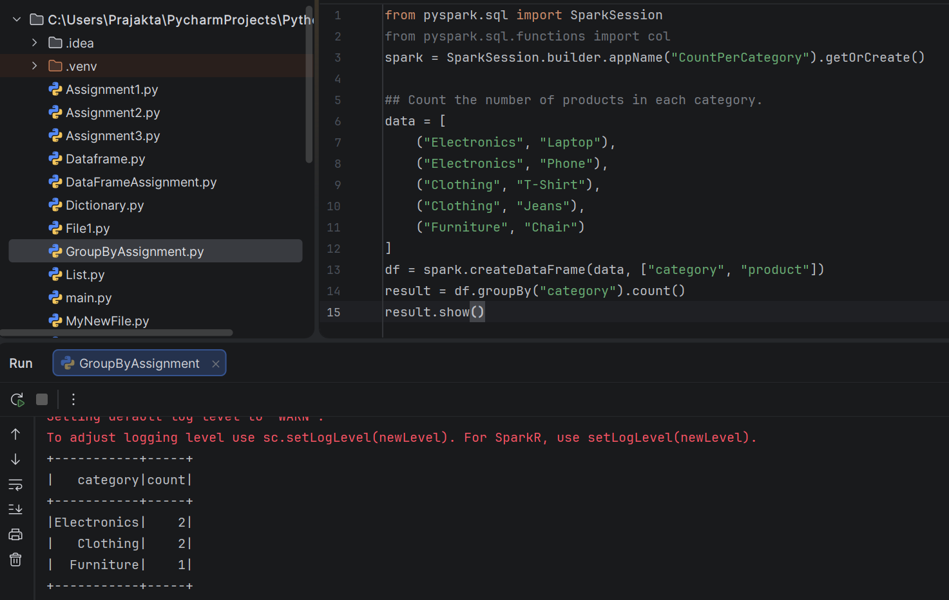

***************************************************************************
2. Find Minimum, Maximum, and Average Price per Product
Sample Data:
val data = List(
("Laptop", 1000),
("Phone", 500),
("T-Shirt", 20),
("Jeans", 50),
("Chair", 150)
)Question: Calculate the minimum, maximum, and average price for each product.
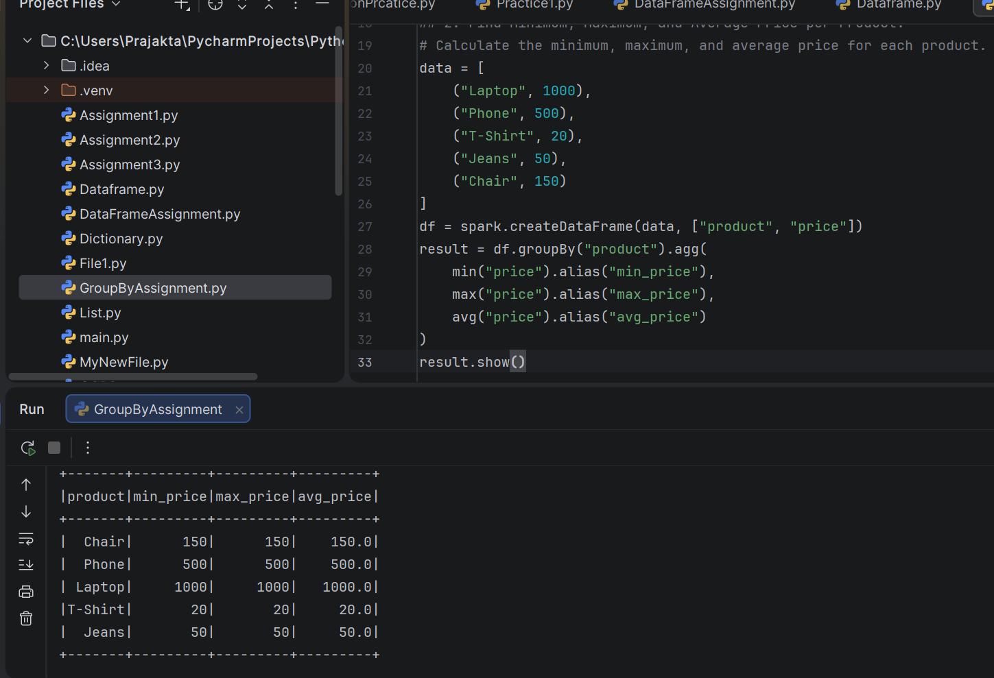
***************************************************************************
3. Group Sales by Month and Year
Sample Data:
val data = List(
("2023-01-01", "New York", 100),
("2023-02-15", "London", 200),
("2023-03-10", "Paris", 300),
("2023-04-20", "Berlin", 400),
("2023-05-05", "Tokyo", 500)
)Question: Group sales by month and year, and calculate the total amount for each
month-year combination.
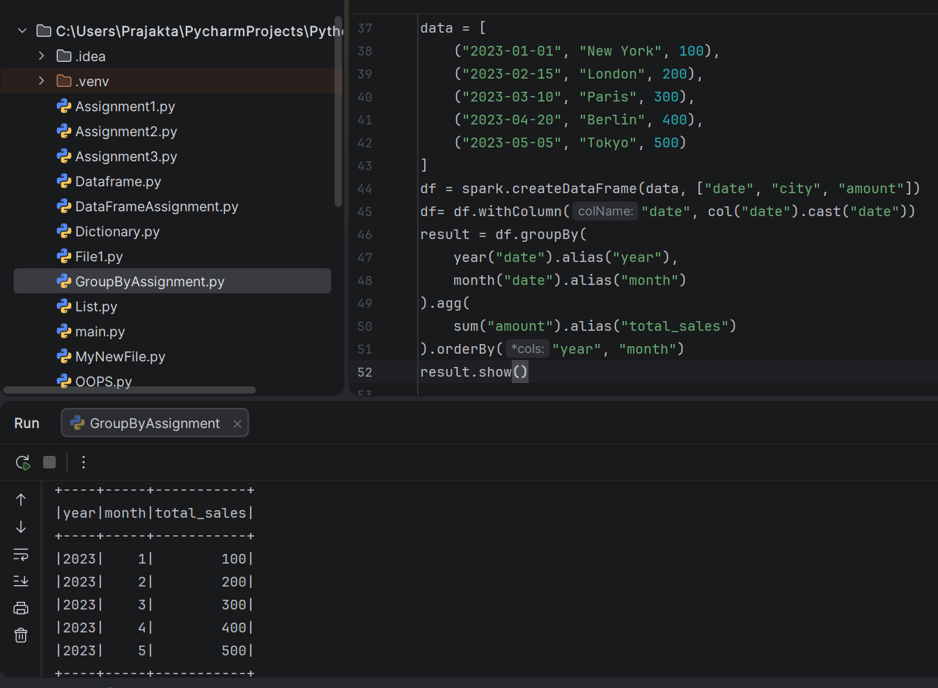
***************************************************************************
4. Find Top N Products by Sales
Sample Data:
val data = List(
("Laptop", "order_1", 2),
("Phone", "order_2", 1),
("T-Shirt", "order_1", 3),
("Jeans", "order_3", 4),
("Chair", "order_2", 2)
)
Question: Find the top 5 products (by total quantity sold) across all orders.
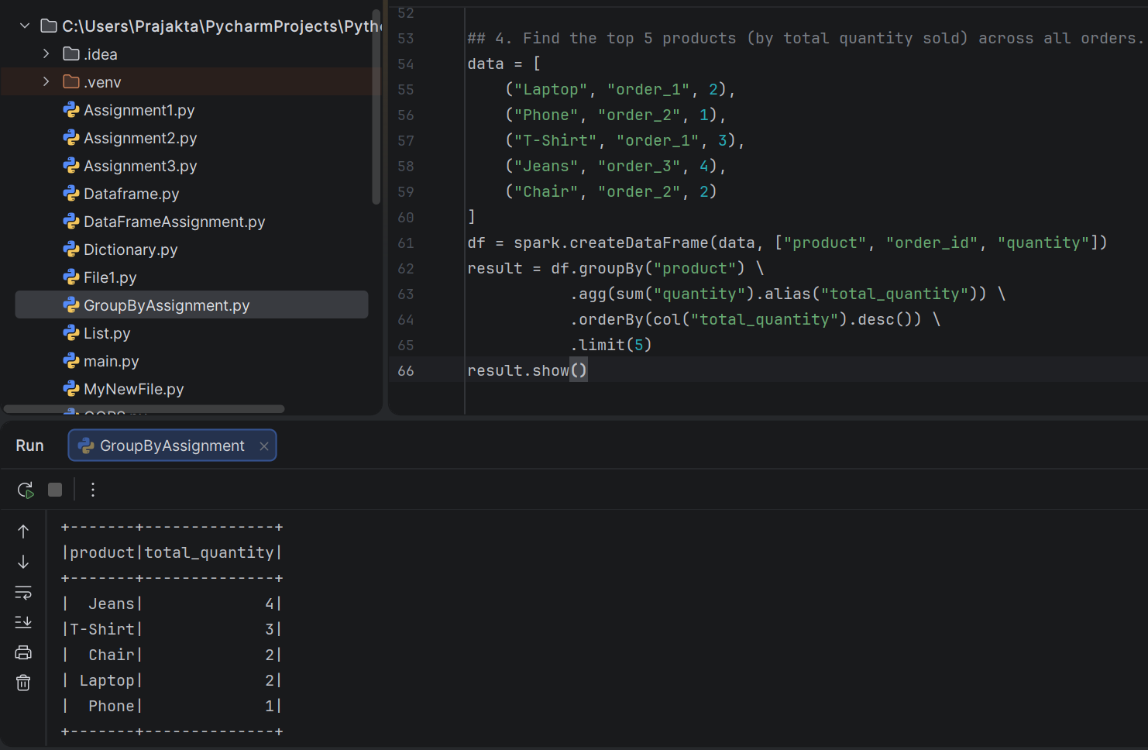
***************************************************************************
5. Calculate Average Rating per User
Sample Data:
val data = List(
(1, 1, 4),
(1, 2, 5),
(2, 1, 3),
(2, 3, 4),
(3, 2, 5))
Question: Calculate the average rating given by each user.
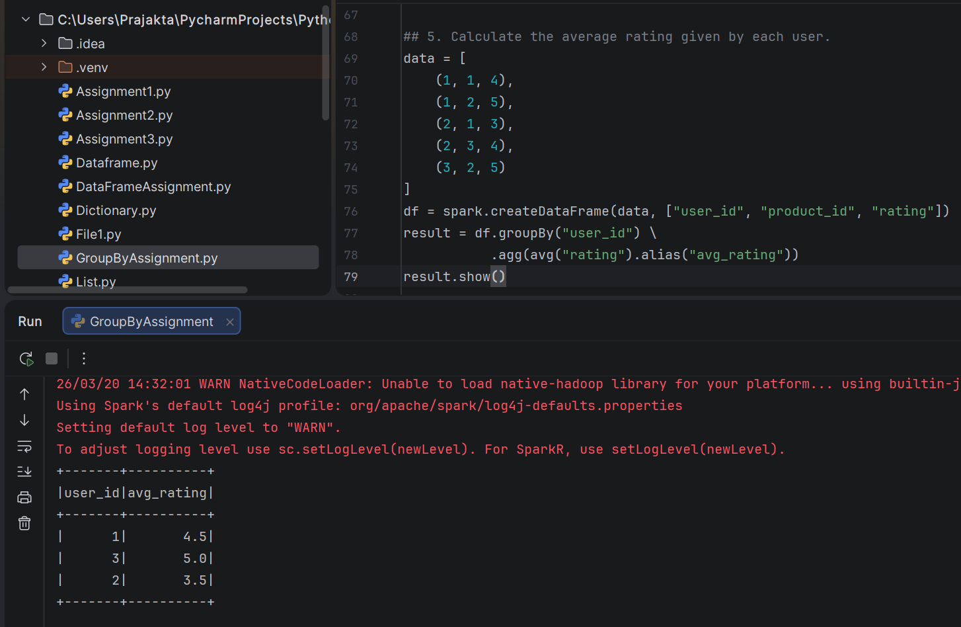
***************************************************************************
6. Group Customers by Country and Calculate Total Spend
Sample Data:
val data = List(
(1, "USA", "order_1", 100),
(1, "USA", "order_2", 200),
(2, "UK", "order_3", 150),
(3, "France", "order_4", 250),
(3, "France", "order_5", 300))
Question: Group customers by country and calculate the total amount spent by
customers in each country.
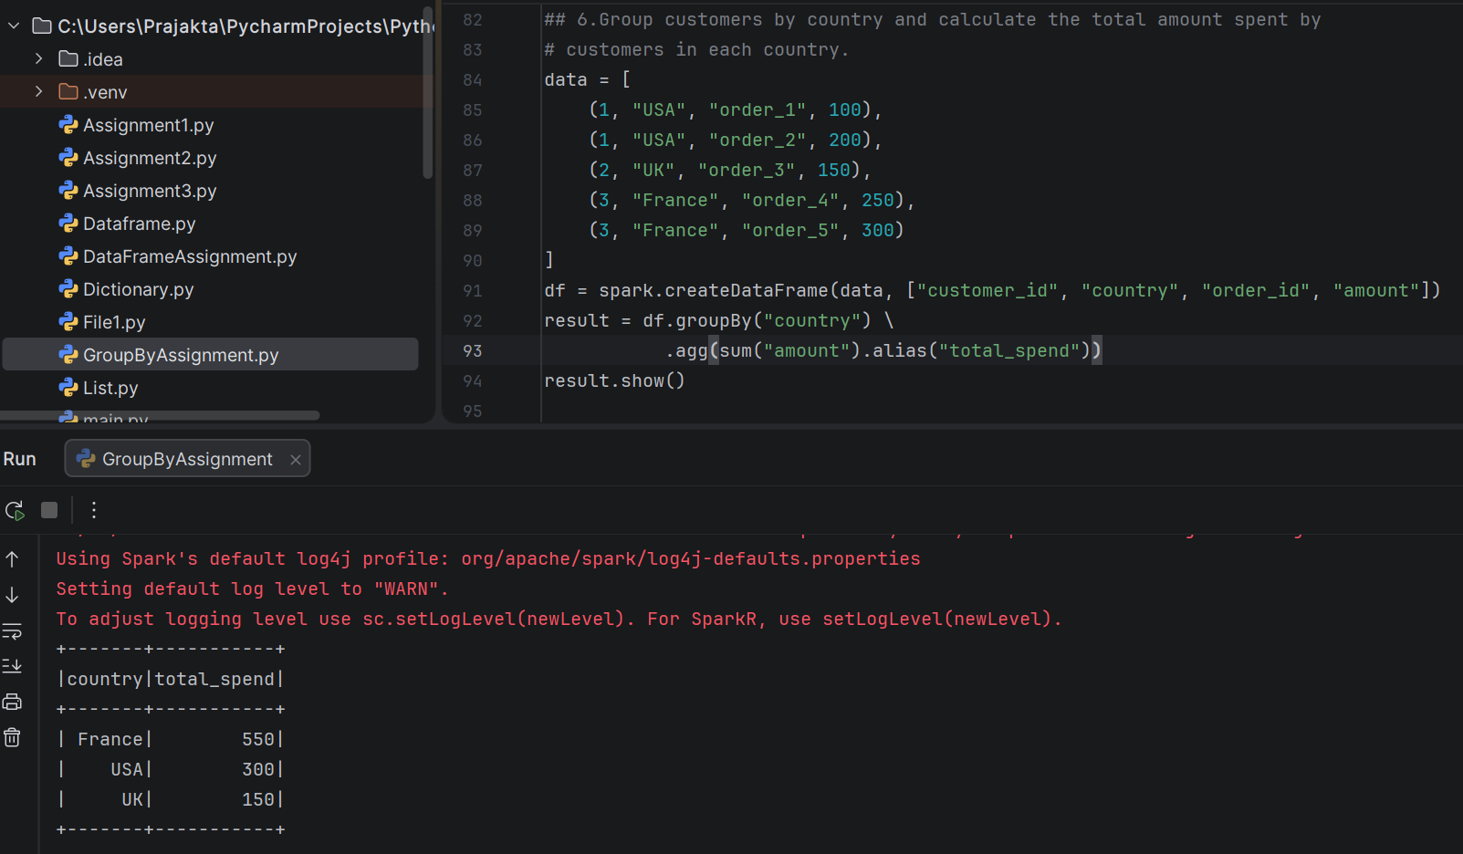
***************************************************************************
7. Find Products with No Sales in a Specific Time Period
Sample Data:
val data = List(
("Laptop", "2023-01-01"),
("Phone", "2023-02-15"),
("T-Shirt", "2023-03-10"),
("Jeans", "2023-04-20"))
Question: Identify products that had no sales between 2023-02-01 and 2023-03-31.
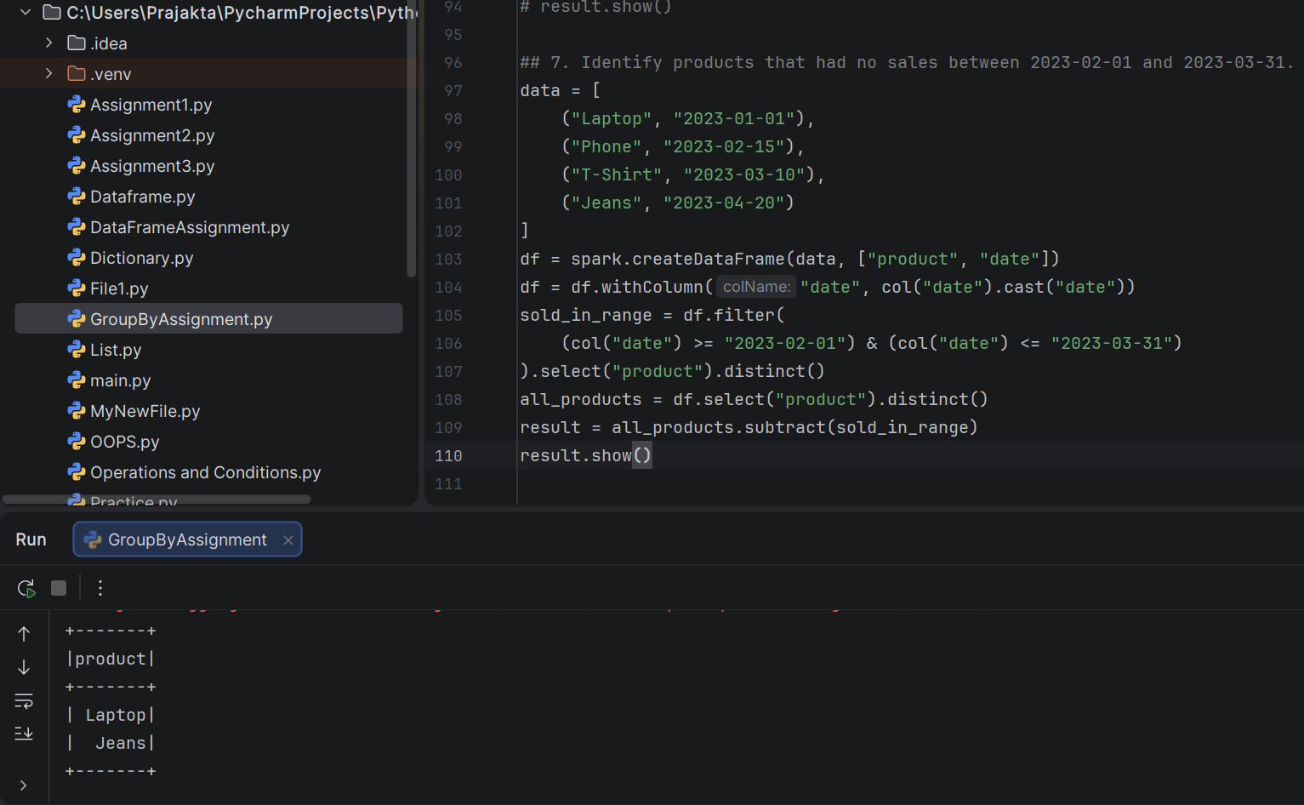
***************************************************************************
8. Calculate Order Count per Customer and City
Sample Data:
val data = List(
(1, "New York", "order_1"),
(1, "New York", "order_2"),
(2, "London", "order_3"),
(2, "London", "order_4"),
(3, "Paris", "order_5"),
(3, "Paris", "order_6"),
(4, "Tokyo", "order_7"),
(5, "Berlin", "order_8"))
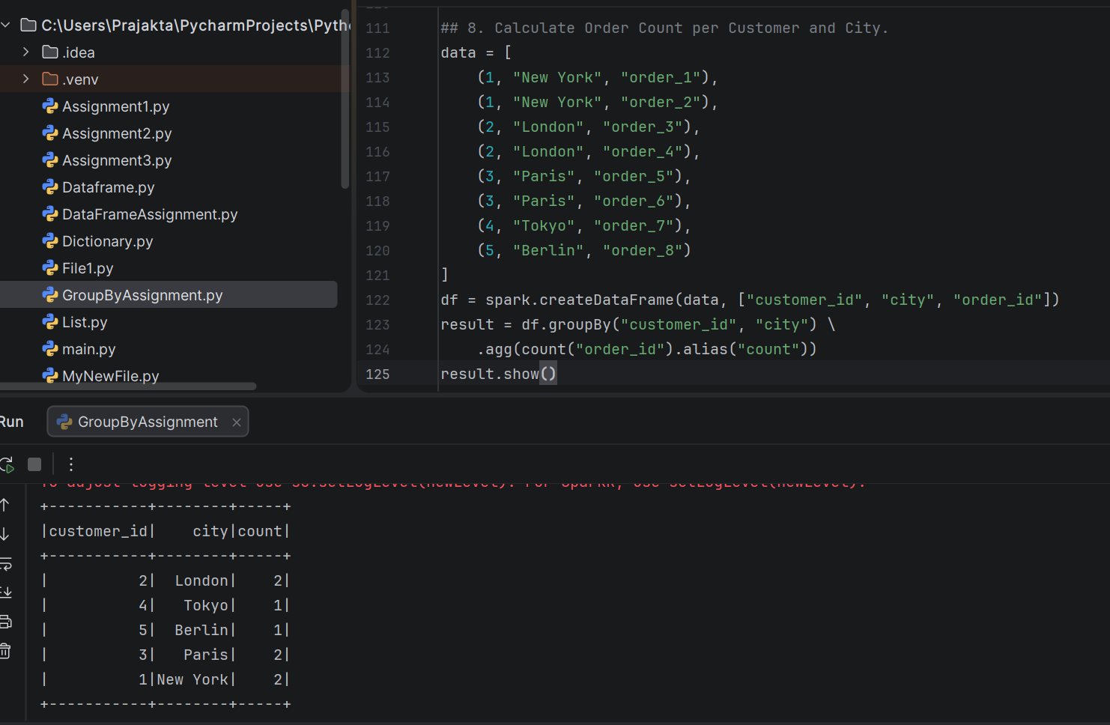
***************************************************************************
9. Group Orders by Weekday and Calculate Average Order Value (when-otherwise)
Sample Data:
val data = List(
("2023-04-10", 1, 100),
("2023-04-11", 2, 200),
("2023-04-12", 3, 300),
("2023-04-13", 1, 400),
("2023-04-14", 2, 500))
Question: Group orders by weekday (use dayofweek) and calculate the average order
value for weekdays and weekends using when and otherwise.
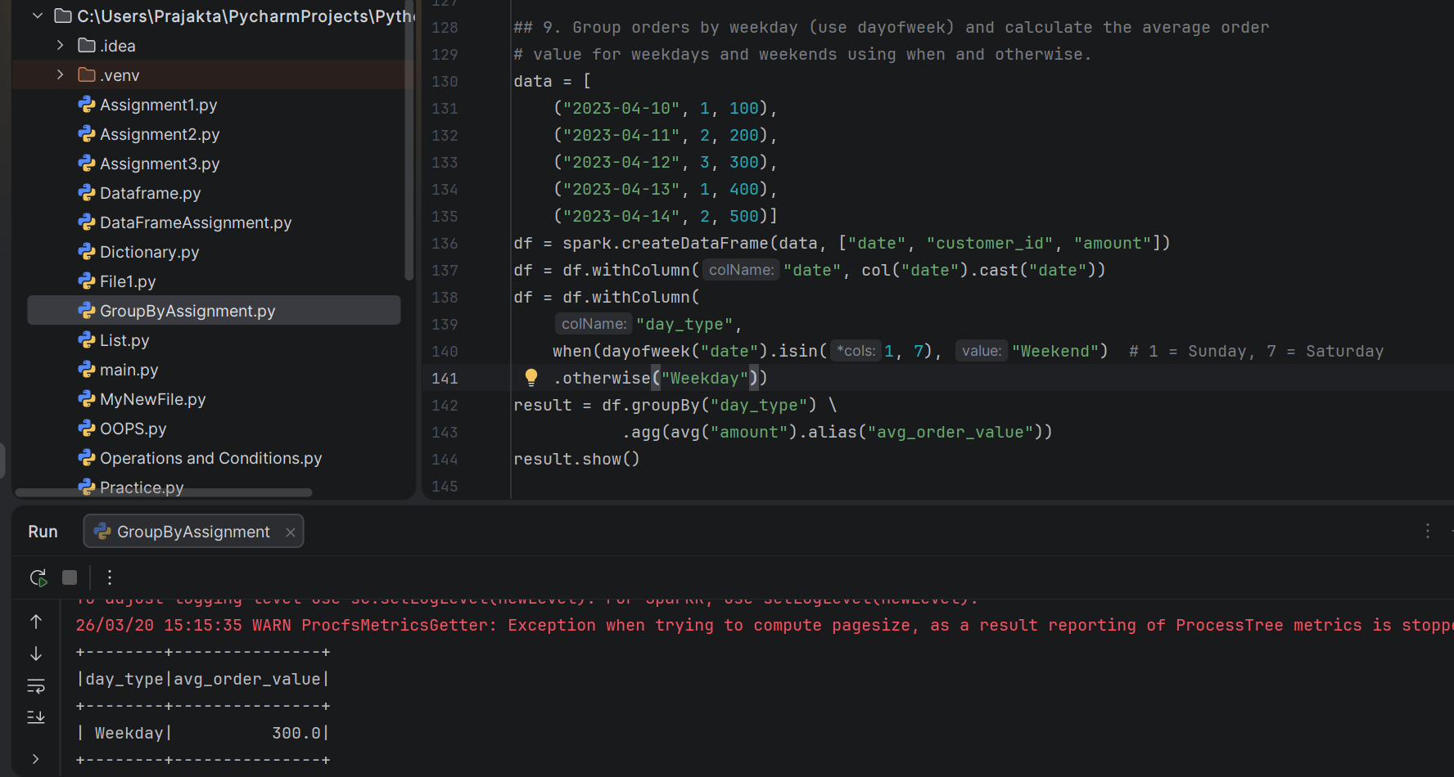
***************************************************************************
10. Filter Products Starting with "T" and Group by Category with Average Price
Sample Data:
val data = List(
("T-Shirt", "Clothing", 20),
("Table", "Furniture", 150),
("Jeans", "Clothing", 50),
("Chair", "Furniture", 100))
Question: Filter products starting with "T" and group them by category, calculating the
average price for each category.
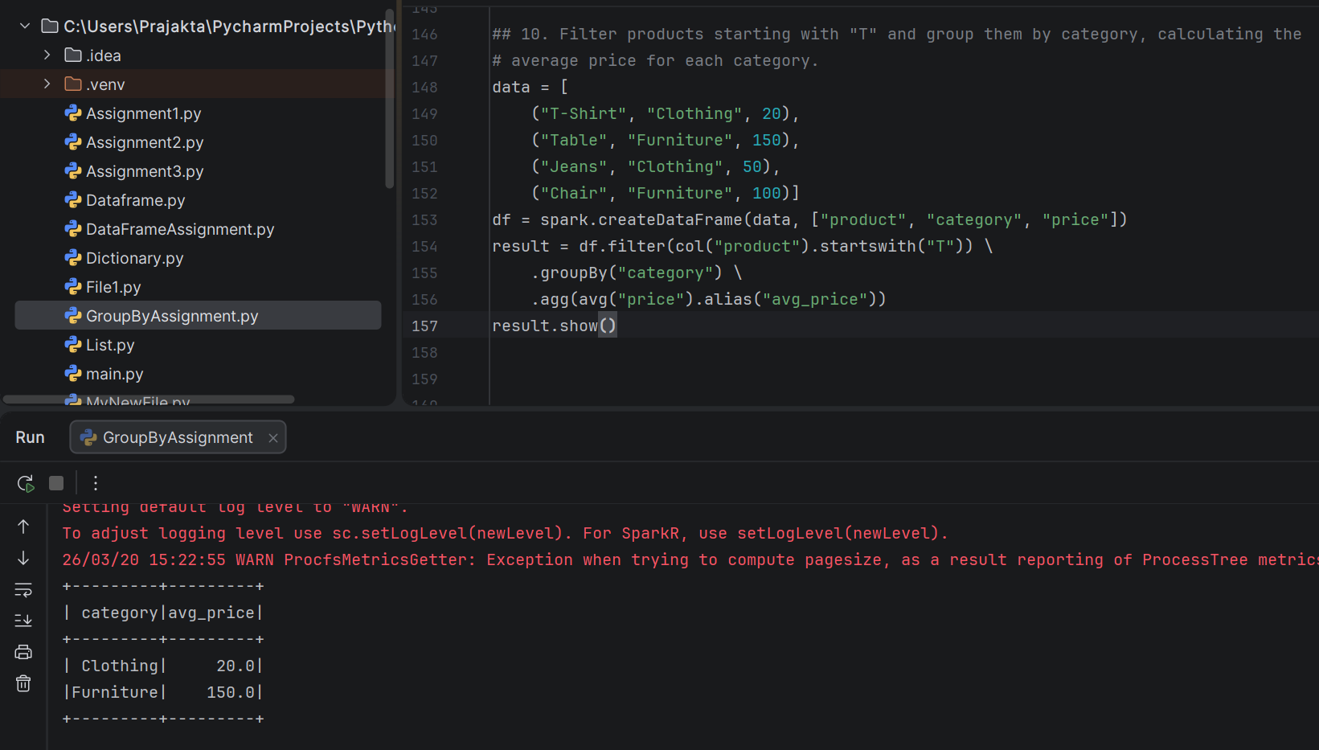
***************************************************************************
11. Find Customers Who Spent More Than $200 in Total
Sample Data:
val data = List(
(1, "order_1", 100),
(1, "order_2", 150),
(2, "order_3", 250),
(3, "order_4", 100),
(3, "order_5", 120))
Question: Group customers by customer ID and calculate the total amount spent. Filter
customers who spent more than $200 in total.
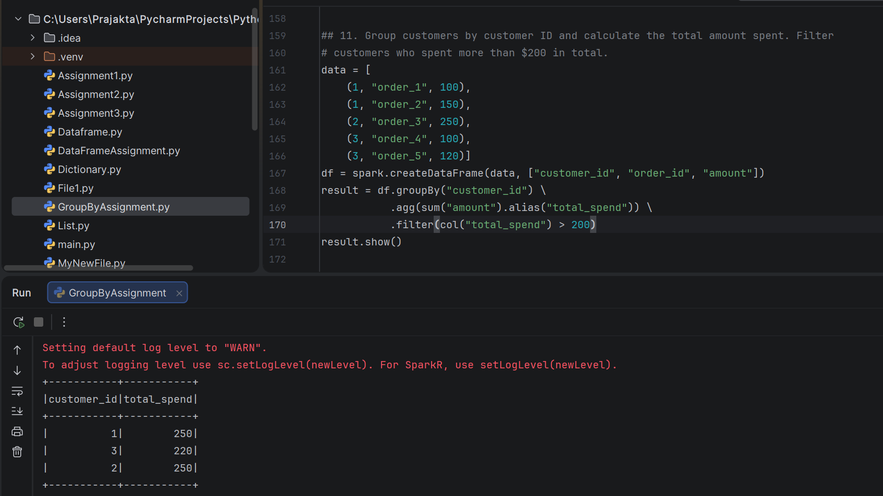
***************************************************************************
12. Create a New Column with Order Status ("High" for > $100, "Low" Otherwise)
Sample Data:
val data = List(
("order_1", 150),
("order_2", 80),
("order_3", 220),
("order_4", 50))
Question: Group orders by order ID and create a new column named "order_status"
with values "High" for orders with an amount greater than $100, and "Low" otherwise,
using withColumn.
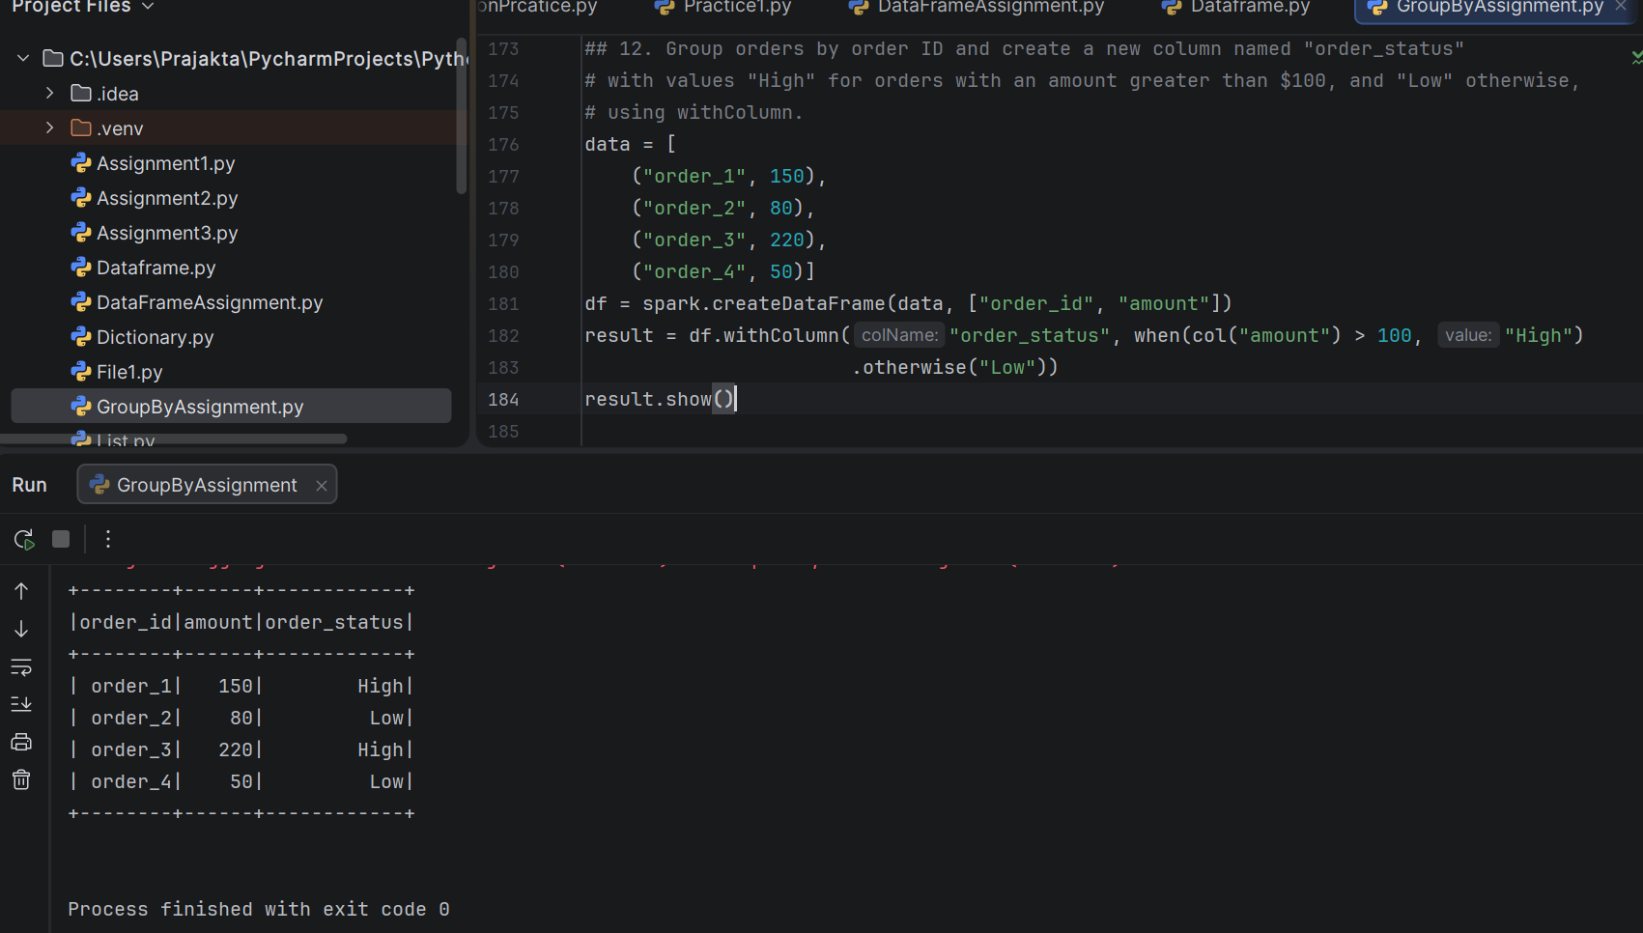
***************************************************************************
13. Select Specific Columns and Apply GroupBy with Average
Sample Data:
val data = List(
("Laptop", "Electronics", 1000, 2),
("Phone", "Electronics", 500, 1),
("T-Shirt", "Clothing", 20, 3),
("Jeans", "Clothing", 50, 4))
Question: Select only "product" and "price" columns, then group by "product" and
calculate the average price.
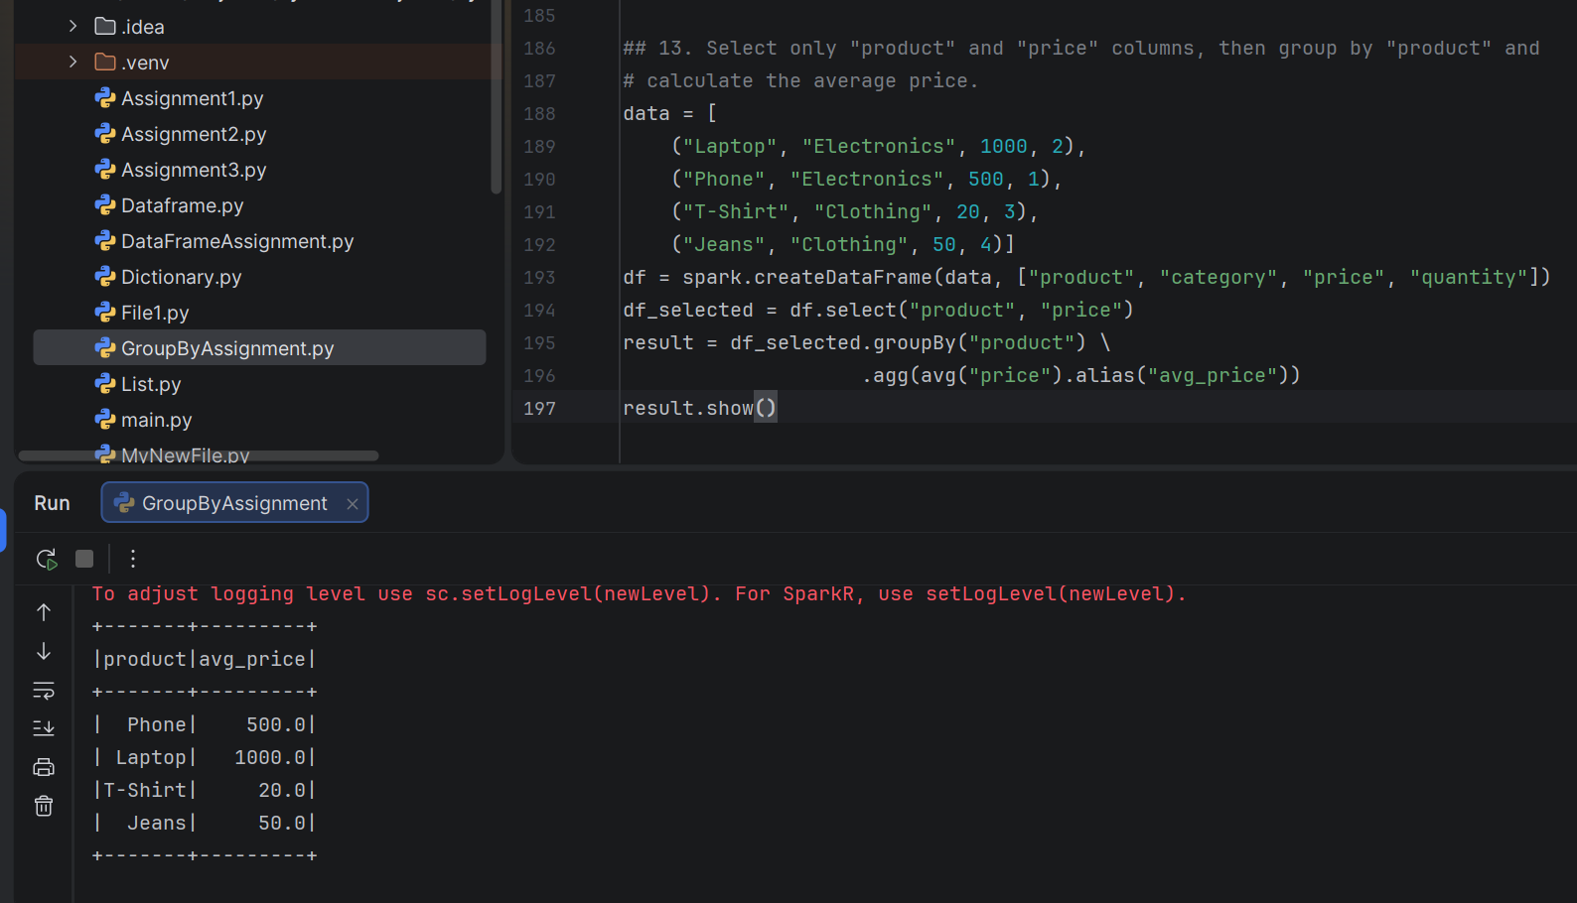
***************************************************************************
14. Count Orders by Year and Month with Aggregation Functions (count, sum)
Sample Data:
val data = List(
("2023-01-01", 1, 100),
("2023-02-15", 2, 200),
("2023-03-10", 3, 300),
("2023-04-20", 1, 400),
("2023-05-05", 2, 500))
Question: Group orders by year and month, and calculate the total number of orders
and total amount for each month-year combination
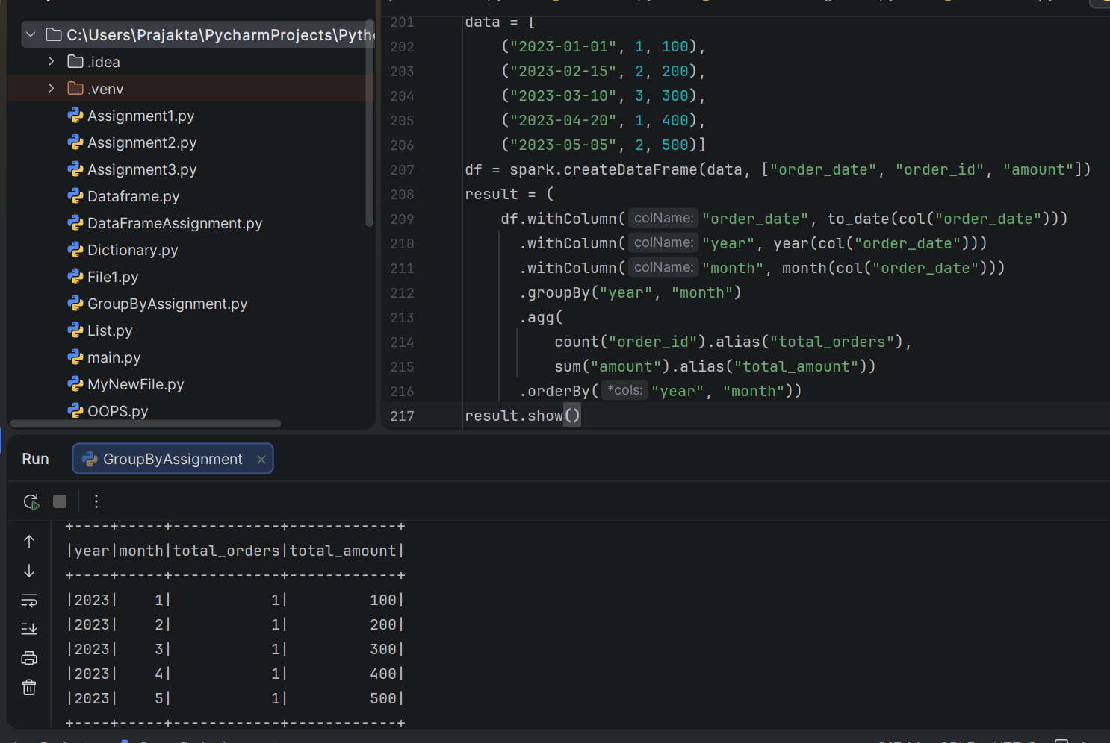
***************************************************************************
15. Find Products with Highest and Lowest Sales in Each Category (Top N)
Sample Data:
val data = List(
("Laptop", "Electronics", 2),
("Phone", "Electronics", 1),
("T-Shirt", "Clothing", 3),
("Jeans", "Clothing", 4),
("Chair", "Furniture", 2),
("Sofa", "Furniture", 1))
Question: Group by category and find the top 2 products (by total quantity sold) within
each category.
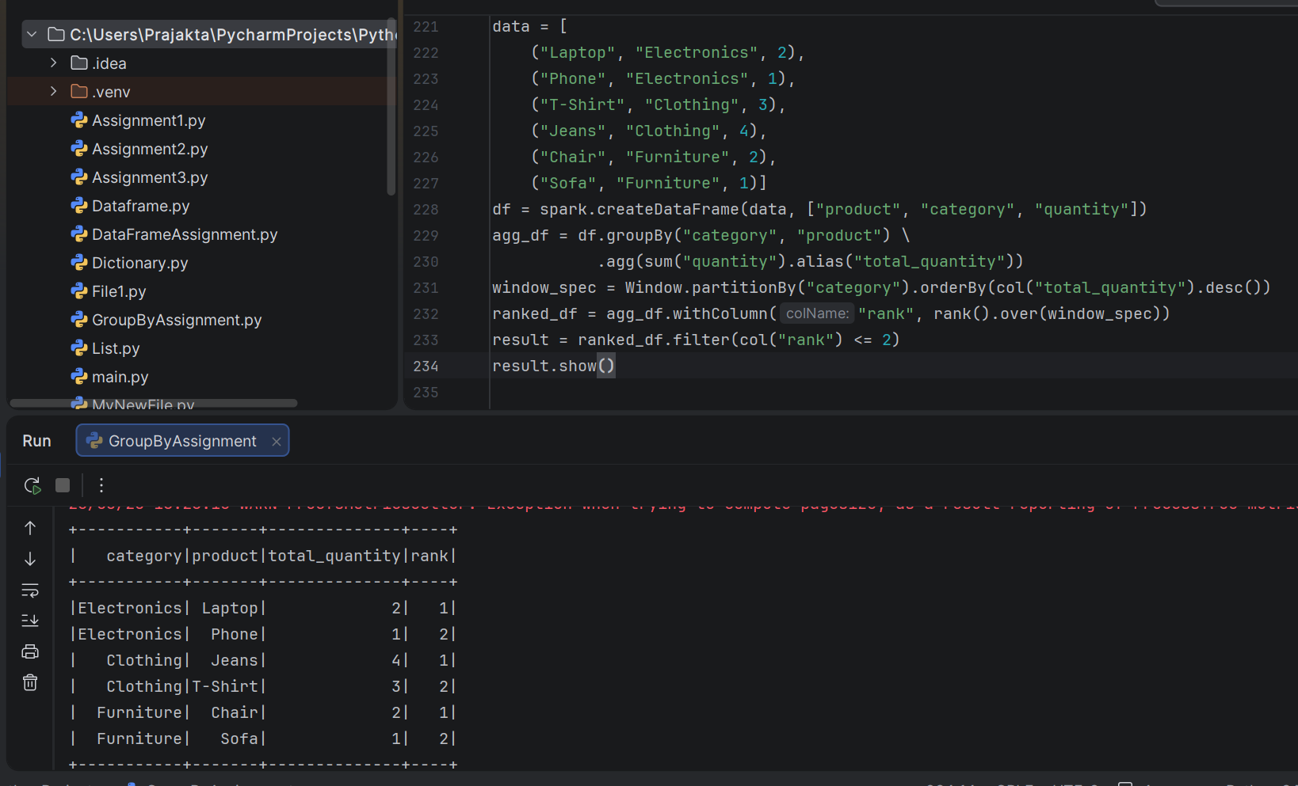
***************************************************************************
16. Calculate Average Rating per Product, Weighted by Quantity Sold
Sample Data:
val data = List(
(1, "order_1", 4, 2),
(1, "order_2", 5, 1),
(2, "order_3", 3, 4),
(2, "order_4", 4, 3),
(3, "order_5", 5, 1))
Question: Group by product ID, calculate the average rating, weighted by the quantity
sold for each order.
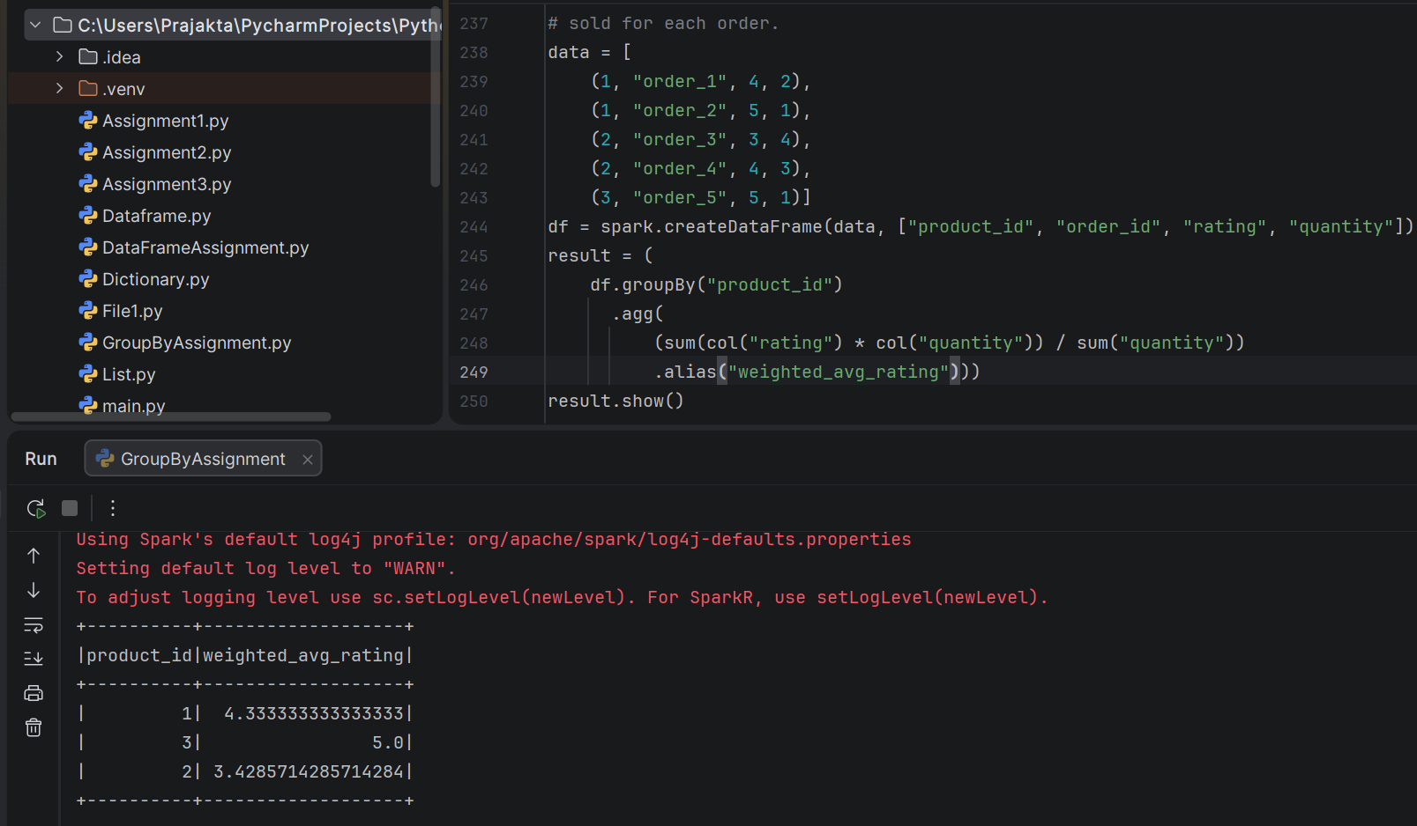
***************************************************************************
17. Find Customers Who Placed Orders in More Than Two Different Months
Sample Data:
val data = List(
(1, "2023-01-01"),
(1, "2023-02-15"),
(2, "2023-03-10"),
(2, "2023-03-20"),
(3, "2023-04-20"),
(3, "2023-05-05"))
Question: Group by customer ID and count the distinct number of months in which they
placed orders. Filter customers who placed orders in more than two months.
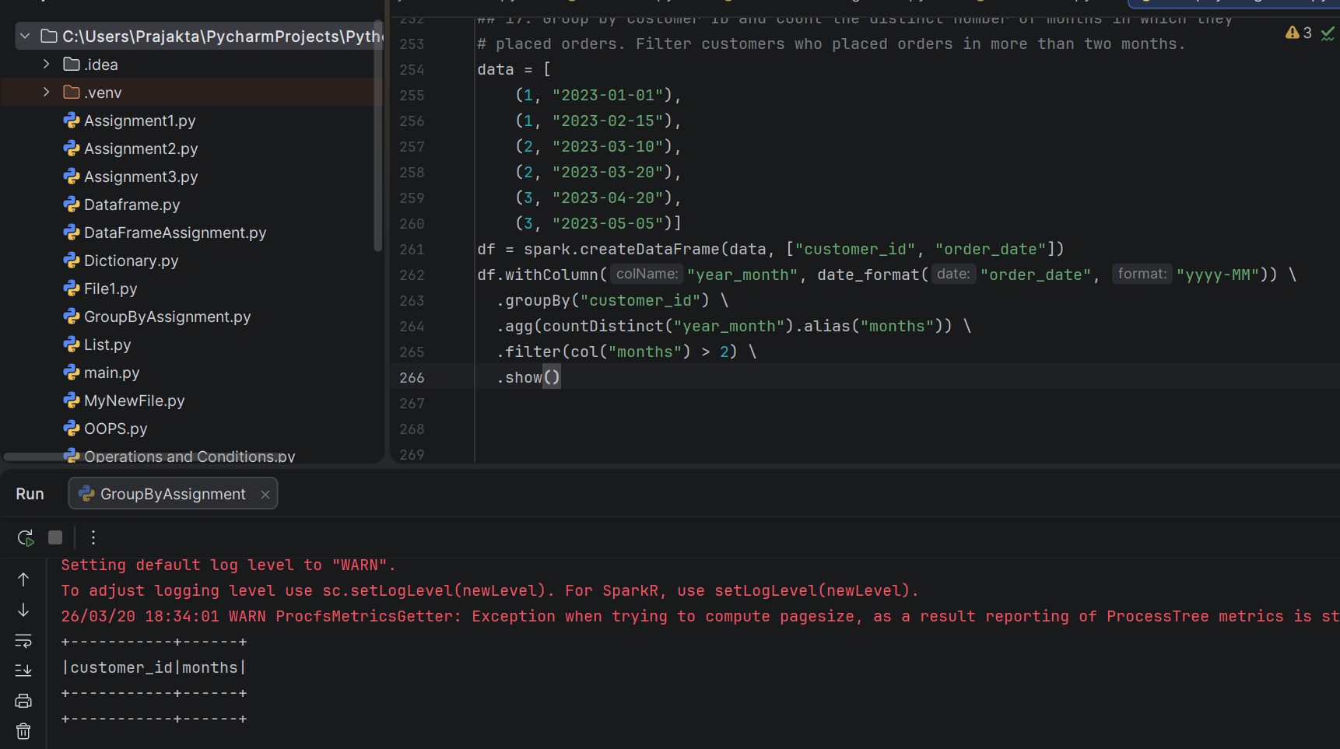
***************************************************************************
18. Group by Country and Calculate Total Sales, Excluding Orders Below $50
Sample Data:
val data = List(
("USA", "order_1", 100),
("USA", "order_2", 40),
("UK", "order_3", 150),
("France", "order_4", 250),
("France", "order_5", 30))
Question: Group by country, calculate the total sales amount, excluding orders with an
amount less than $50.
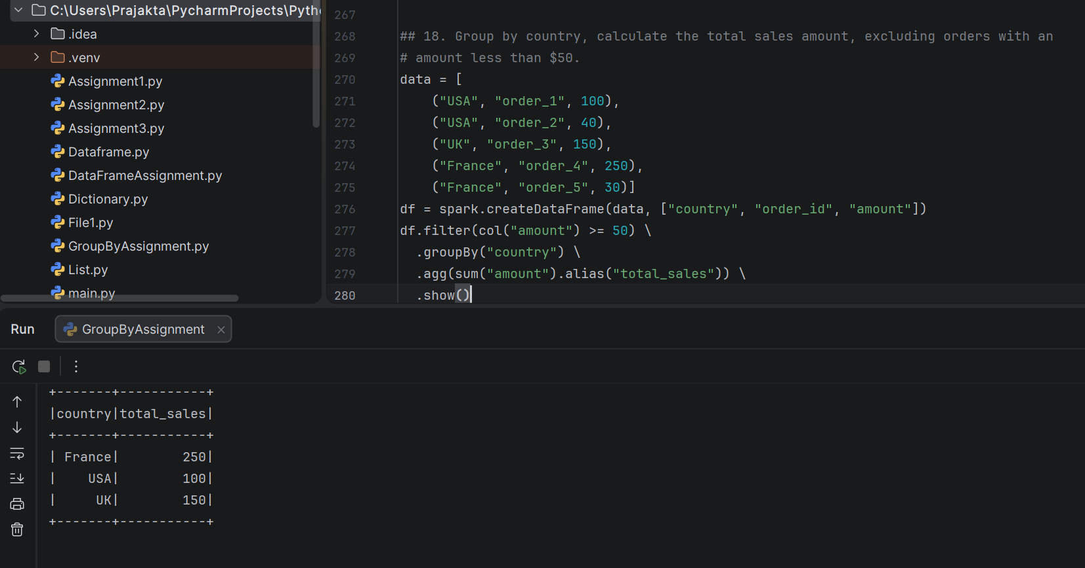
***************************************************************************
20. Group by Category and Calculate Standard Deviation of Price
Sample Data:
val data = List(
("Laptop", "Electronics", 1000),
("Phone", "Electronics", 500),
("T-Shirt", "Clothing", 20),
("Jeans", "Clothing", 50),
("Chair", "Furniture", 150),
("Sofa", "Furniture", 200))
Question: Group by category and calculate the standard deviation of price for each
category.
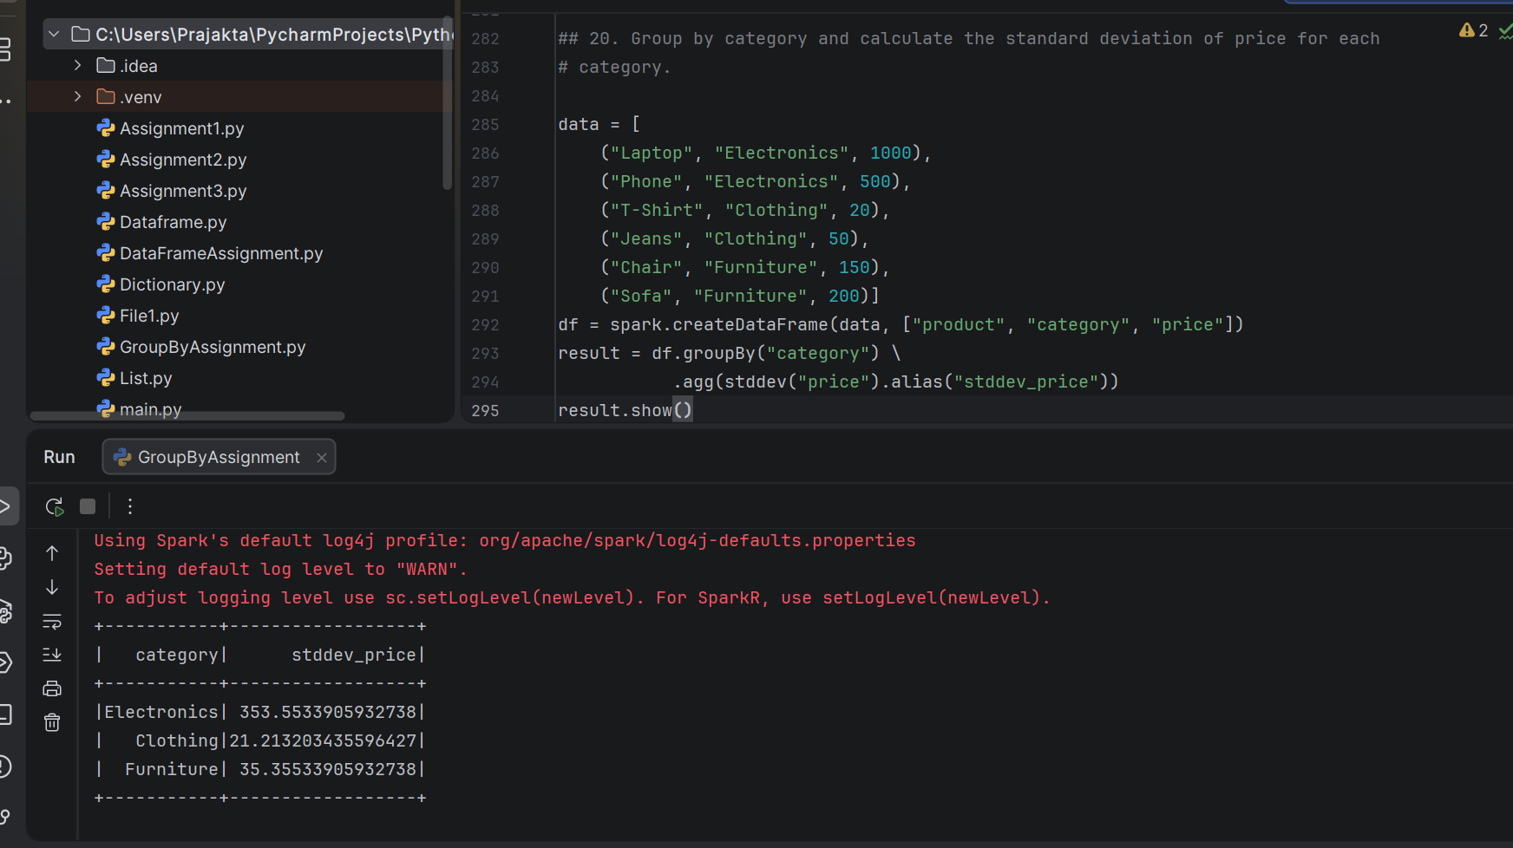
***************************************************************************
21. Find Most Frequent Customer City Combinations
val data = List(
(1, "New York"),
(1, "New York"),
(2, "London"),
(2, "Paris"),
(3, "Paris"),
(3, "Paris"))
Question: Group by customer_id and city, and find the most frequent city for each
customer.
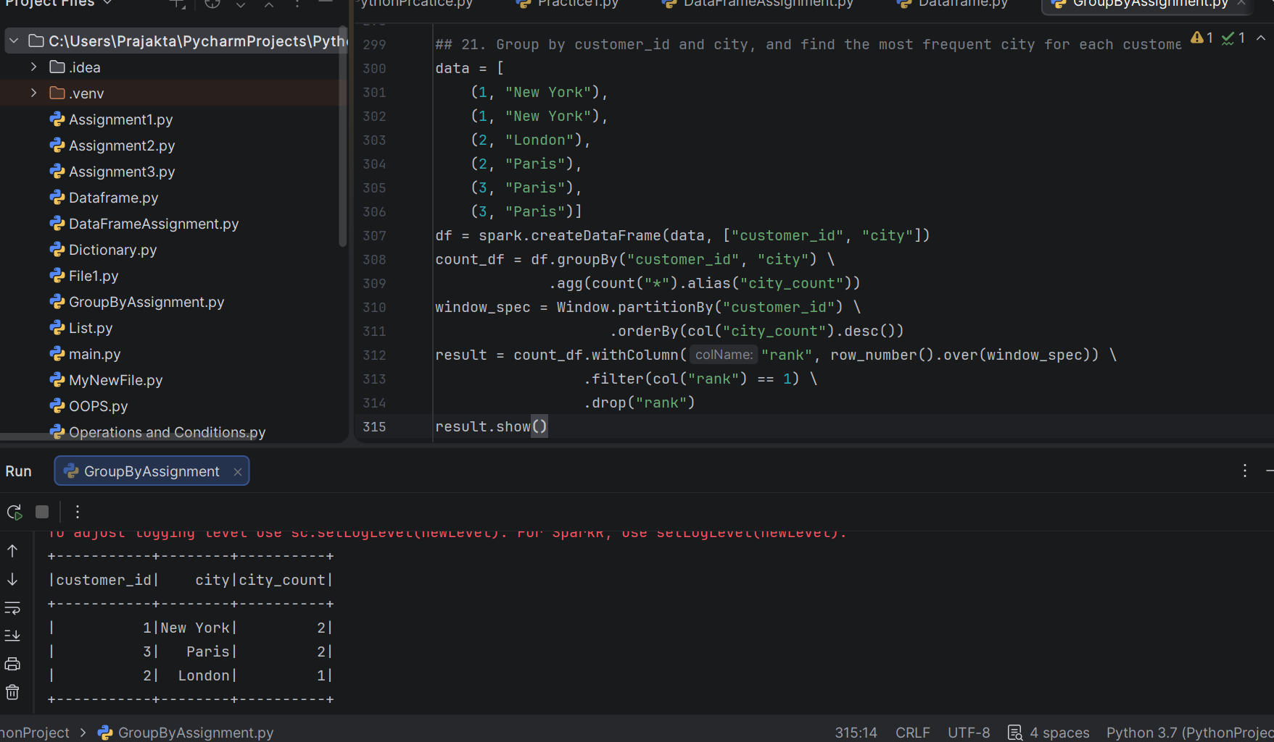
***************************************************************************
22. Calculate Customer Lifetime Value (CLTV) by Year
Sample Data:
val data = List(
(1, "2022-01-01", 100),
(1, "2023-02-15", 200),
(2, "2022-03-10", 300),
(2, "2023-04-20", 400),
(3, "2022-05-05", 500),
(3, "2023-06-06", 600))
Question: Group by customer_id and year (use year), calculate the total amount spent
for each customer in each year. This can be used to calculate CLTV.
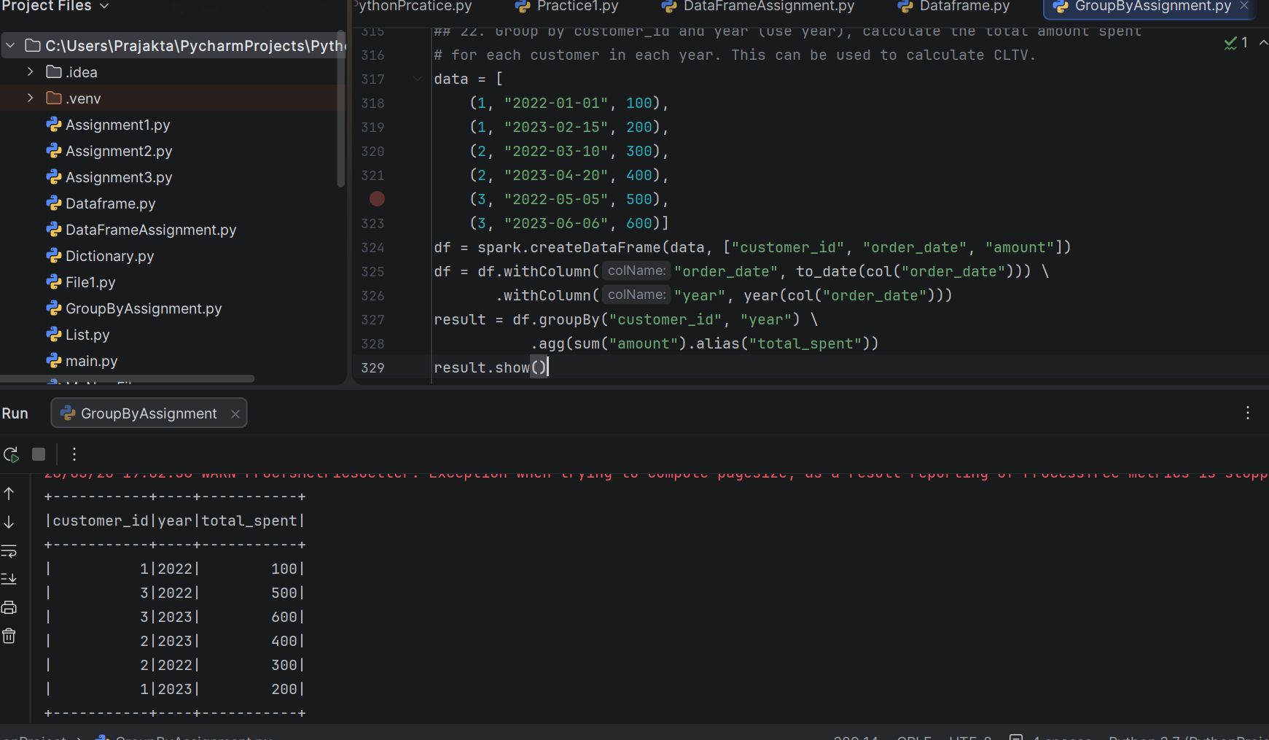
***************************************************************************
25. Calculate Average Order Value by Country, Excluding Cancelled Orders
Sample Data:
val data = List(
("USA", "order_1", 100, "Shipped"),
("USA", "order_2", 40, "Cancelled"),
("UK", "order_3", 150, "Completed"),
("France", "order_4", 250, "Pending"),
("France", "order_5", 30, "Shipped"))
Question: Group by country, calculate the average order value, excluding orders with
a "Cancelled" status



